Doncaster Methodist Circuit 
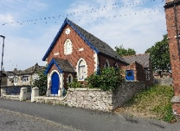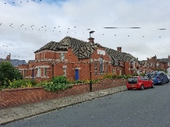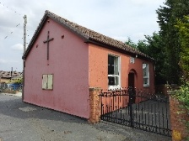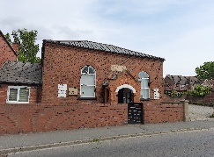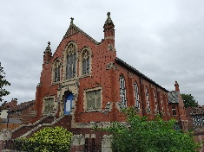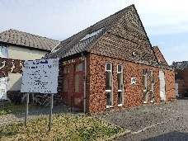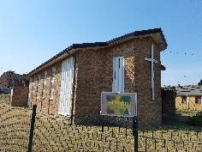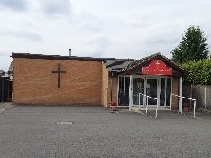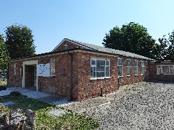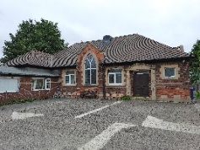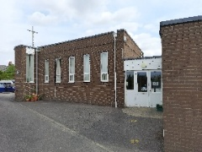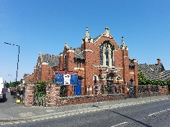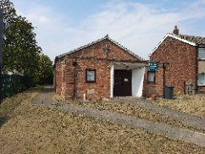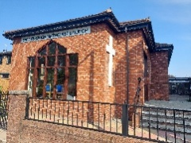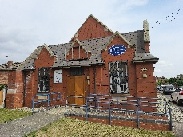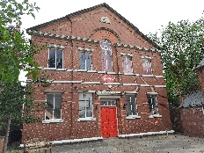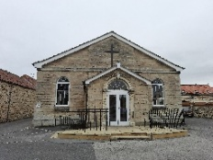

DISCIPLESHIP AND MISSION
IN THE NAME OF CHRIST
WINTER EXTENDED NOTICES
CIRCUIT ACTIVITIES
Bible Study – Prayer Groups

Bible Study – Barnby Dun Methodist Chapel –
every 3rd Saturday @ 11.30 am following the coffee morning.

Bible Study – Cantley Methodist Church –
No set dates – check the Circuit Notices

Bible Study – Flintwood Methodist Church –
Check Circuit Notices

Bible Reflection – Hatfield Woodhouse Methodist Church –
1st Monday of the month – 1.30 pm – 2.00 pm

Bible Study/Discussion – Tickhill Methodist Church –
Wednesday Fellowship – weekly – 7.30 pm – 8.30 pm (not during school holidays)

Zoom Prayer – Hosted by Flintwood Methodist Church –
Weekly – Tuesday evening 7.30 pm – 8.30 pm (Zoom codes from Chris Ogley)

Prayer Time – Thorne Methodist Church –
4th Saturday of the month – 10.30 am -11.00 am

Circuit Prayer Breakfast – 2nd Saturday of the month –
8.00 am – 9.30 am – visit a different church each month. Enjoy a free light breakfast and time of prayer. Check the Circuit Notices.
Other Activities
Weekday Holy Communion – SMC –
3rd Monday of the month – 2.00 pm – 3.00 pm using the Methodist Worship Book – led by Rev Tom Read.

CONNECT Contemporary Worship – Tickhill Methodist Church
A monthly contemporary service led by Rev John Henry.

Mission Matters Forum – a Circuit wide meeting to discuss matters that matter in Mission of our Churches, our Circuit, throughout Britain and the World. Check the Circuit Notices for dates and locations.

Fayres – Spring Summer Autumn and Winter fayres bring us together and give us an opportunity to support each other. Check the Circuit Notices for dates and locations.

July 2025
Cantley Methodist Church

Farewell Service – Rev Gill Newton at Cantley Methodist Church
On Sunday 13th July 2025, Rev Gill Newton held her last service in the Doncaster Methodist Circuit as she leaves the role of Sheffield District Chair to move to a new role based in the Conference Office responsible for Candidating in Ministry, Ministerial training amongst other things.
Rev Gill has been District Chair for 11 years and has preached throughout the Doncaster Circuit throughout this time. This was her last service in our Circuit at Cantley Methodist Church.
Churches from around the Circuit were invited and given a warm welcome and it was a full congregation.
Rev Gill focussed on bible month John Chapter 2 – Jesus changes water into wine. This was an event that revealed the glory of Jesus. How can our faith be deepened from this reading? It reminds us of God's generosity, abundance and the quality of His love. How Jesus loved life, loved people and how he wants to join in our celebrations, our sadness, our everyday lives. By trapping God inside a church, we risk other people not sharing in the good news and in the joy of Jesus being a part of their lives. We need to show people outside of church that God is a joyful God, that He can make a difference in our lives. He wants to transform us and make us the very best we can be, giving us a fullness of life.
By praying every day for God to help us and mould us and believing in this power of prayer this is where real change and transformation comes.

With God the best is still to come for us all.
Following the service, we shared in refreshments and memories, wishing Rev Gill well and good luck in the next chapter of her life and ministry.
A wonderfully uplifting service with good singing – Farewell Rev Gill and Godspeed.
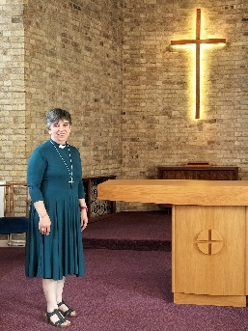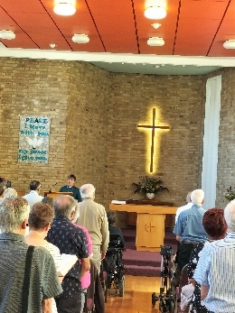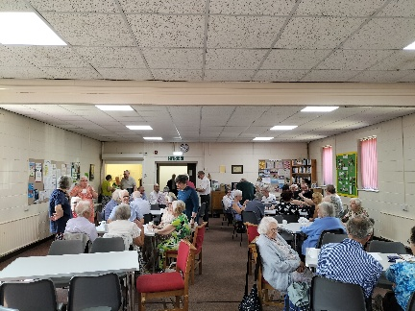
-ooooooooooooo-
Eco Church at Cantley Methodist Church
Early in 2024 Rev Tom Read asked the members of Cantley how they felt the church should move forward. From his questionnaire, it was clear that one of the things most concerning members was caring for the environment.
For some time we had been interested in the Eco Church project. Eco Church is an award scheme for churches in England and Wales run by the Christian environmental charity A Rocha, working to equip Christians and churches to protect and restore the environment, for God, nature and all people. It is free to take part and includes a toolkit of resources and an online award survey. The survey checks what we are doing as a church and allows us to build up points towards our Eco Church award
We had a coffee morning in May 2024 to launch the project and let the congregation know more about it. Eco Church has become a regular item in the Cantley Newsletter, with information about recycling and updates on our progress. We began to increase the biodiversity of our grounds by planting a small area with pollinator-friendly plants and shrubs. The Eco Church survey was being revised, and we were asked by A Rocha to wait until the new survey was available before entering our information online.
We started to complete the new Eco Church Survey in early 2025 at the Cantley Mission Forum, a group of interested members who wanted to share ideas. At that meeting we looked at the ‘Worship and Teaching’ category and were surprised at how much we already did. We also identified other things we could do easily to increase our score. Our guidance to preachers planned at Cantley now includes a request to consider creation care in their service planning. Rev John Henry and Pastor Sean Worsley led a Lent Course focussing on Caring for Creation.
Similarly, a meeting with the Finance and Property Team to look at the ‘Land and Nature’ and ‘Buildings and Energy’ categories showed us that we could ‘tick off’ several questions already. The next meeting of the Cantley Mission Forum will look at the ‘Lifestyle’ and ‘Global Engagement’ categories.
We would be delighted if we could complete enough of the Eco Church survey to gain a Bronze Award, but that would be a bonus. The important thing for us is that we are doing as much as we can to care for the environment. As Christians we want to do all we can to look after God’s Creation. It is the process of questioning what we can do that is important. It’s important too to realise that things that benefit creation will also benefit our church. Installing LED lights, for example, reduces the demand for electricity and lowers the church’s energy bill. Letting the grass grow long in part of the grounds, and encouraging wild flowers saves effort spent on mowing and helps insects and birds at the same time.
In mid-June we met Sam Roberts, the District Communications Officer, to talk about our progress. We’re hoping there will be an article in the next edition of the District News. The intention is to show what it’s like to begin the Eco Church journey, and how churches can start with small things and make progress at their own pace. Any changes we make are significant if they help us care for God’s creation.
If you’re interested in seeing what you could do in your church, search online at ecochurch.arocha.org.uk or contact us. We’re happy to talk.
Mary and Mike Scott
-ooooooooooooo-
Memories
Netherhall Road Methodist Church (? 1950’s)
This picture has been sent in – do you remember your Sunday School Anniversary celebrations? Could you be in this picture?
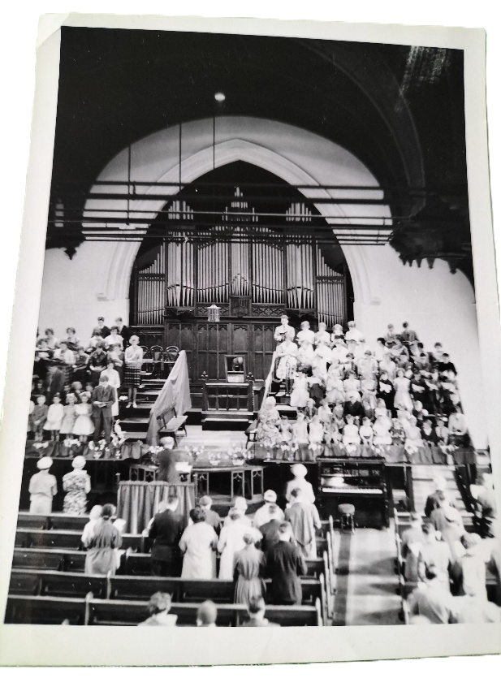
-ooooooooooooo-

August 2025
Tickhill Methodist Church
Tickhill Methodist Outreach Team

In April 2025, TMOT made an appeal to the Circuit for votes to get a share of Tesco’s Stronger Starts fund.
‘Each year, Stronger Starts provides grant awards of up to £1,500 to local community projects, with a particular focus on children and young people. Three groups in every community have been shortlisted to receive grant awards and Tesco customers can vote for the group they think should take away the top award in their local Tesco store.

Tickhill Methodist Outreach Team (Feeding the homeless) is one of the groups on the shortlist in Doncaster. Every Monday, a team of volunteers from the church and local community prepares and distributes a well-balanced sandwich-based meal and a hot drink to homeless and vulnerable people in Doncaster. By voting for this group, you will help to ensure that some of the most vulnerable in society continue to receive a meal on Monday evenings.’

Voting opened in Tesco stores from April to the end of June 2025. Customers cast
their vote using a blue token given to them at the check-out each time they shopped Tescos.

TMOT came second place and were awarded a grant of £1000 – a fantastic achievement and a huge boost in being able to feed the homeless and vulnerable.
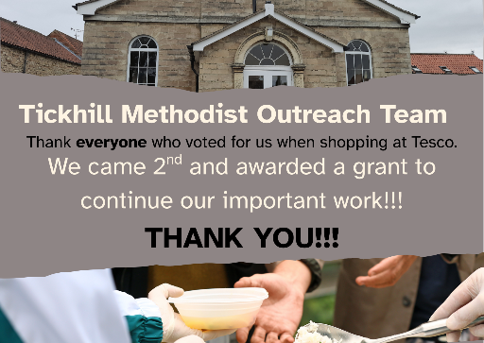
-ooooooooooooo-
General Knowledge (provided by Mr Peter Harris)
THE PRESIDENT OF THE PRIMITIVE METHODIST CONFERENCE

If you open Wikipedia and ask for the “List of presidents of the Methodist Conference” you will find that from 1820 to 1932 it lists “Presidents of the Wesleyan Methodist Conference” and “Presidents of the Primitive Methodist Conference.” “Primitive” in this context means “original” or “simple” – going back to the time
of Jesus and the twelve disciples.

This list of Presidents of the Wesleyan Methodist Conference and Presidents of the Primitive Methodist Conference shows that in 1893 Rev. John Stephenson was the President of the Primitive Methodist Conference – AND HE WAS BORN AND BROUGHT UP IN THE VILLAGE OF ADWICK-LE-STREET!

After 1932 there is a list of Presidents and Vice-Presidents of the Methodist Conference of the Methodist Church of Great Britain, the Vice-President being a lay person.
-ooooooooooooo-

September 2025
Tickhill Methodist Church

Feeding the Homeless and Vulnerable in Doncaster
Tickhill Methodist Outreach Team (TMOT) continues to feed around 50 homeless and vulnerable people outside Christchurch every Monday evening. We are one of several voluntary meal services that run daily apart from Saturdays, when currently there doesn't seem to be any provision.
We are managed by Tickhill Methodist Church although many of the volunteers come from the community in Tickhill and from other churches. We are fortunate to have enthusiastic, committed volunteers, many of whom have been with us since the project started. Please contact Mandy on 07745167300 for information on volunteering with the team.
The food preparation team of 4 works hard to produce 6 loaves of sandwiches and 4 flasks of hot chocolate each week and we are able to offer 5 different sandwich fillings. This choice has evolved from listening to our homeless friends who are always very appreciative.
The basic meal is funded by the Church and we are very fortunate to receive donations from individuals and from Tickhill and District Lions which fund "extras" of a chocolate bar, a sausage or cheese and onion roll and drink of hot chocolate with every meal. Recently a grant of £1000 has been awarded by Tesco via the "Tesco Stronger Starts Scheme" after voting took place at local Tesco stores. Many thanks to all who voted!
We have had donations of money, clothing and sleeping bags whilst at the handout and one evening were even donated a large chocolate celebration cake to share out by a couple celebrating their 50th wedding anniversary! People are so thoughtful.
There is always a queue of hungry people waiting outside Christchurch at 6pm when the team of 4 volunteers distribute the meals. Sometimes people stay around for a chat whilst they eat and it's encouraging to hear when someone is given their own accommodation and supported to get their life back on track.
We are grateful for donations of sleeping bags, coats, socks, gloves and warm hats but don't have the storage space for other clothing, although we do try to distribute any that we are given.
Historically at Christmas we have appealed for gifts of toiletries, warm accessory clothing and sweets/chocolate so that we could provide a gift bag to every homeless person. These have been well received but we may do something a little different this year, depending on what other services are providing. I will update you via the Circuit News after our annual meeting later in September.
Thank you for your prayerful support of this project. Mandy Bird
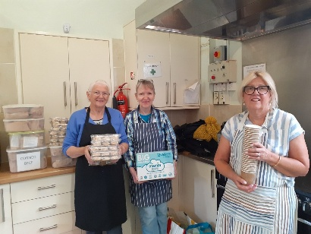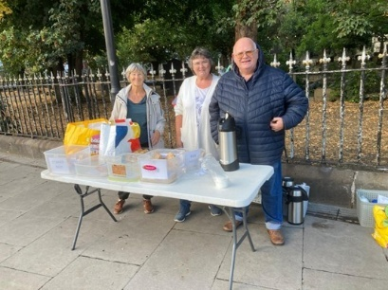
-ooooooooooooo-
Doncaster Methodist Circuit
Mission Matters Forum – Guest Speaker
In 2024, Rev. John Henry established Mission Matters, a Circuit-wide forum open to all members across the Circuit to engage in discussions regarding matters that matter regarding mission. The forum serves as a constructive environment for thoughtful dialogue, aiming to inspire and support churches in advancing mission initiatives within local communities, across congregations, throughout Britain, and globally.
At our September meeting, we were pleased to welcome former Circuit Minister Rev Arthur Harbottle, who shared insights into his mission work in Haiti, as well as that of his family. This was a informative and thought-provoking presentation. Rev Arthur left us with four pointers to help with Mission in our churches and used by the team in Haiti:-

1) Listen – to what the Community needs.
2) Enable – a “Working With” NOT “Doing For” strategy
3) Plan – ensure there is a long-term plan to factor in resilience
4) Progressive – work out feasible

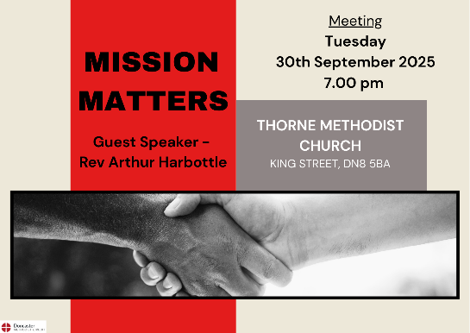
-ooooooooooooo-

OCTOBER 2025
Harvest 2025 across the Circuit

Across the Circuit we celebrated Harvest.

At Alder Grove Methodist Church, windowsills were decorated by different members of the congregation. The Vestibule area was decorated with a wonderful seascape. The church also hosted a service for the local preparatory Sycamore School. The children sang harvest songs and were invited to join in various harvest related activities. The children brought their generous harvest gifts. A joyous afternoon!

Flintwood Methodist Church welcomed Robyn Hawke (husband of our former Superintendent Rev Chris Hawke) to preach their Harvest celebration. While Tickhill Methodist Church welcomed back former Pastor Alice Curry to take their Harvest service.
Many of our churches served a Harvest Lunch following the service or met together on another date. A valuable time of fellowship and friendship.
The Doncaster Methodist Circuit was thrilled to be able to donate their gifts of food and toiletries to the various Food Banks across the City.

A huge thank you to everyone who helped decorate our churches, arranged flowers, played music, participated, and made generous donations.

What a fantastic celebration of God’s gifts to us – our earth, our produce, and our ability to share!
Take a look at some of the pictures taken of the Harvest Festivals around the Circuit.
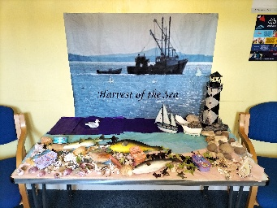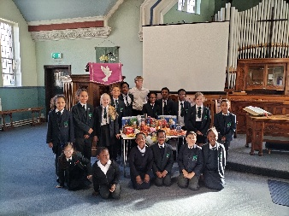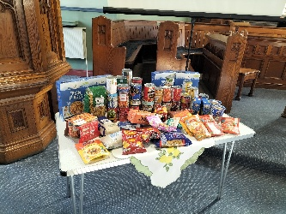
Alder Grove Methodist Church

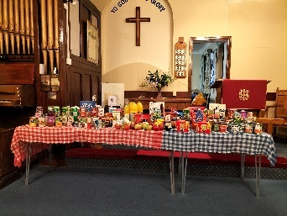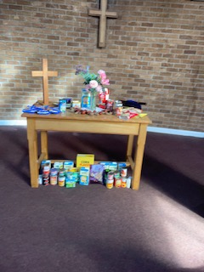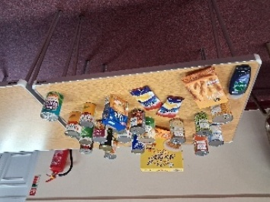
Auckley Methodist Church Bentley Methodist Church Dunsville Methodist Church

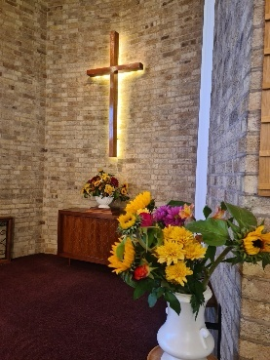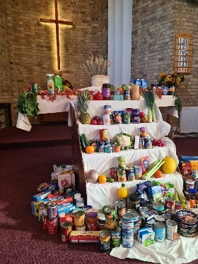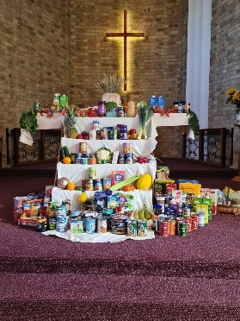
Cantley Methodist Church

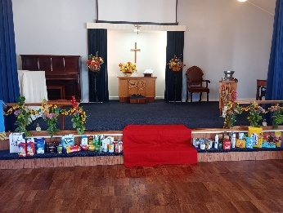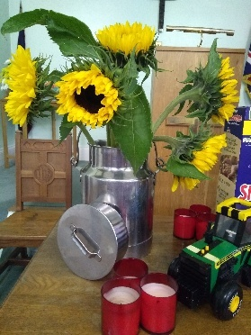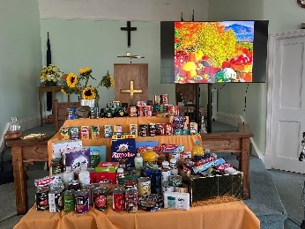
Flintwood Methodist Church Harworth Methodist Church

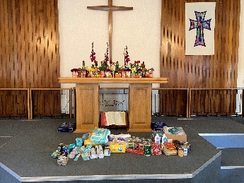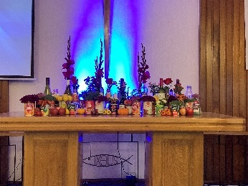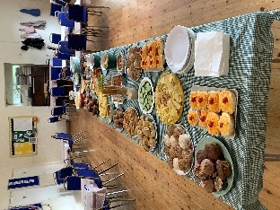
Sprotbrough Methodist Church

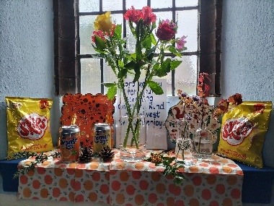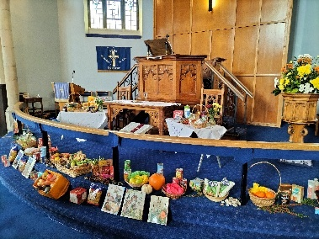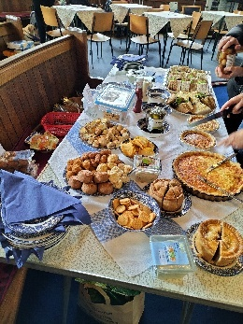
St Andrew’s Methodist Church

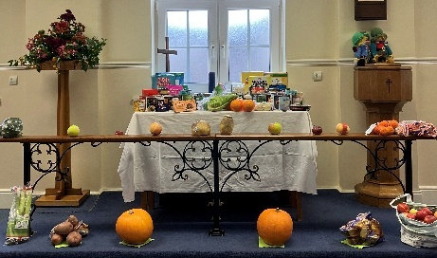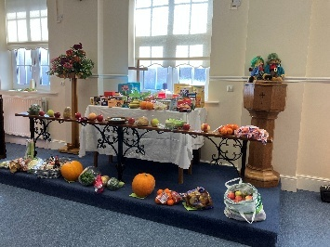
Stainforth Methodist Church

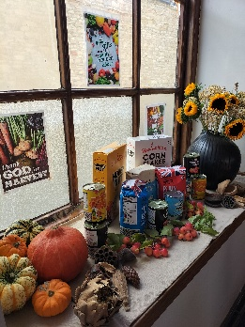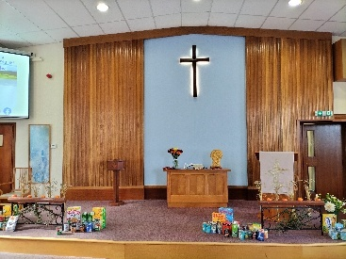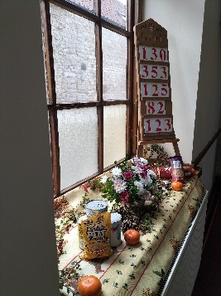
Tickhill Methodist Church

-ooooooooooooo-

Doncaster Methodist Circuit

Anna Chaplaincy

In October 2025, the Circuit employed our first Anna Chaplain – Mr Roger Thirlwell. Roger is a member of St Andrew’s Methodist Church, his roots being at Adwick-Le-Street Methodist Church. This had been a passion and idea of Roger’s for some time, first presented at the Circuit Meeting in March 2025. The idea and passion grew and after approval at the June Circuit Meeting, Roger began his training. Here’s what he has to say.

What is Anna Chaplaincy?

Anna Chaplaincy is founded on the story of Anna in St Luke’s Gospel v 36-37. Anna was a widow who served in the Temple and after
seeing Jesus and his parents in the Temple talked to the people she met during her time there.

When learning about Anna Chaplaincy, I wondered what is the definition of a Chaplain? I subsequently found the following in the
Training manual: -
'The word chaplain comes from the Latin word for a cloak and the word grew out of the story of St Martin (of Tours) meeting a man begging in the rain with no cloak. If St Martin had met the man’s need by giving him his own cloak, he would have shifted the problem to himself, so instead, he tore his cloak in two and shared it. From this the understanding of a chaplain has developed as someone who shares support with those in the storms of life and offers some spiritual help and direction in difficult times.'
cuh.nhs.org.uk
This describes what Anna Chaplains are trying to do for older people, for it is a ministry designed to support older folk and their
families, in what I describe, as their “twilight” years. Many are living on their own, have or are starting to need additional support from their families or outside services. Others maybe living independently in accommodation designed for the elderly or in residential care. Anna Chaplains meet people with various forms of dementia.
Anna Chaplaincy is a ministry of the Bible Reading Fellowship (BRF). It is a non-judgemental, inter-denominational Christian
ministry, seeking to be alongside people with faith and those with none.
I first learnt about Anna Chaplaincy several years ago, when visiting family in Alton, Hampshire. The founder, Debbie Thrower, a
former TV journalist, lives in the area and the local Anna Chaplaincy team uses the Methodist Church there as their “operational” centre.
In 2025 Brenda died. She’d been a member at St Andrews in the Doncaster Methodist Circuit for many years. It was only towards the end of her life that I realised that I knew very little about Brenda outside of Church. This led me to wondering if there were others in our Circuit who could be in a similar position, living on their own, the Church being very much part of their lives, and then for various reasons, unable to continue being part of the Church’s community.
I believe that Anna Chaplaincy can support those folk, and as importantly you, in making sure that all folk in their “twilight” years will have the opportunity to experience the love of Jesus Christ that Anna Chaplaincy can bring.
Roger Thirlwell
Anna Chaplain, Doncaster Methodist Circuit

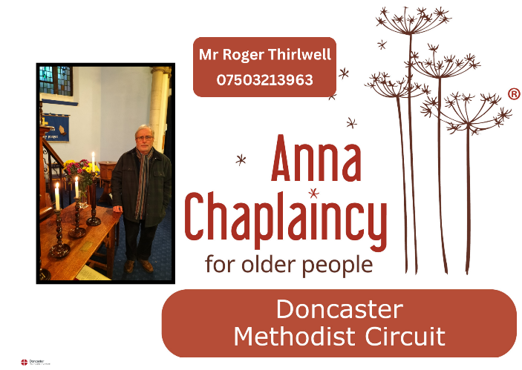
-ooooooooooooo-
Adwick-Le-Street Methodist Church

Coffee Morning for Shoebox Appeal

The full quote — “There are three kinds of lies: Lies, Damned Lies, and Statistics” —
has been attributed to Mark Twain, who himself attributed it to British Prime Minister
Benjamin Disraeli, who might never have said it in the first place!
However, when Jean Gravette (see photo) gave some words of encouragement to those who came to our Coffee Morning she presented us with a few interesting facts:

• 11.11 million shoeboxes are collected worldwide

• 5.5 million children are enrolled on “The Greatest Journey” (a 12-lesson
discipleship course designed for Operation Christmas Child Shoebox recipients)

• 3.2 million children made a first-time commitment for Jesus

• 51% of UK shoeboxes went to hard-to-reach countries where Christians are
persecuted
At this event more than £320 was raised for the postage costs, and at our next
Coffee Morning on Saturday 15th November (which is in aid of the Homeless) all the
completed shoeboxes will be brought.

-ooooooooooooo-
Cantley Methodist Church
jBM Saxophonquartett Concert – in aid of Doncaster Food Bank
On Friday, 24th October, Cantley Methodist Church was honoured to host a concert by the jBM Saxophonquartett, visiting from Germany. The ensemble, featuring soprano, alto, tenor, and bass saxophones, delivered an impressive repertoire ranging from classical to contemporary pieces, showcasing the versatility of their instruments through sophisticated arrangements and exceptional musical skill.
After the performance, attendees enjoyed a wide selection of cakes accompanied by tea and coffee, providing an excellent opportunity for fellowship, networking, and meeting new acquaintances.
The members of the jBM Saxophonquartett generously donated their time, with all proceeds from ticket sales benefiting the Doncaster Food Bank. Furthermore, the group’s bass saxophonist, an avid beekeeper, contributed jars of honey brought from Germany, with all sales also supporting the Food Bank.
This event proved to be highly successful, raising over £450 for the Doncaster Food Bank, thereby making a meaningful impact on the local community.
Sincere thanks are extended to the organisers and bakers at Cantley Methodist Church, to the talented members of the jBM Saxophonquartett for their invaluable contribution, and to all who attended and supported this charitable cause.

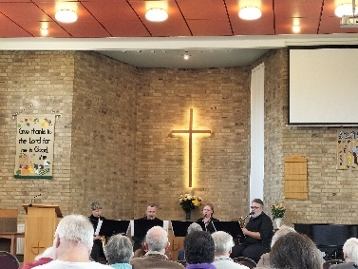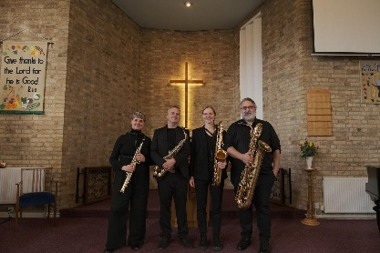
-ooooooooooooo-

NOVEMBER 2025
Stainforth Methodist Church

Stainforth Methodist Church – Centenary

Methodism in Stainforth commenced with the establishment of a Wesleyan Methodist Chapel on Briars Lane in 1820, followed by the addition of a school room.
Subsequently, in 1870, a Primitive Methodist Chapel and school room were constructed on Silver Street.

In 1925, aided by the South Yorkshire Coalfield Mission, a new Wesleyan Methodist Church and Sunday School rooms were completed at the current Church Road location.
The union of Wesleyan, Primitive, and United Methodist churches in 1932 formed what is now known as The Methodist Church.
During the 1960s, the main sanctuary on Church Road was demolished, and the existing school room was renovated to serve as the present worship area.
The centenary of the Silver Street chapel was commemorated in 1970. However, the chapel closed in 1972, resulting in the unification of both congregations at Church Road.
In 2004, significant refurbishment was undertaken at the Church Road building, modernizing the church and adding facilities including office space for the Citizens Advice Bureau and Job Centre.

Margaret provides some information- Interesting to read the reasons for building a chapel, seating nearly 500 people, a large school room and other smaller rooms. The building had central heating, padded tip up chairs, office and a bathroom for the minister. (We have some copies of the booklet available)
A similar publication was printed when the church was 80. The information is mainly from the Doncaster Gazette of February 1924 and 13th November 1925. Interesting to read the sermons from various ministers, Coalfield Clergy and the connexion.

The land was purchased from Hatfield Main Colliery for £100. The money came from various sources, Coalfields Mission and local people whose names & amounts donated were published in the Gazette. Some well-known people from Hull gave generous donations. We were surprised by the generous donations from local people and those who had no connection with Stainforth.

2025 marked the Centenary of Methodism in Stainforth, celebrated with an afternoon service on Sunday, 2nd November, led by former Superintendent Minister Rev Chris Hawke and her husband Robin. All of the hymns we sung were chosen by members of the congregation.
Post-service activities included sharing a commemorative cake and refreshments, providing attendees with the opportunity to engage and reflect on the church's heritage.
On Wednesday 5th November 2025 we hosted a celebration lunch which consisted of cold and hot food, plus cheeses and desserts and another Anniversary cake. We were joined by members, friends, Stainforth CAB and the Smile Group.
Time to chat and remember.

Photographs and memorabilia were on display, which proved to be of interest to many.
Thank you to all who attended and helped during that week.
Thank you to all who in the past, members, friends, volunteers, clergy and Local Preachers who have supported the Stainforth cause.
God Bless – Margaret Wilson
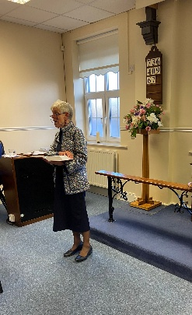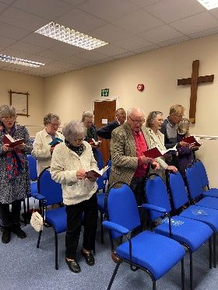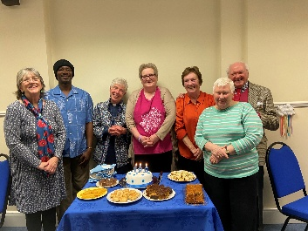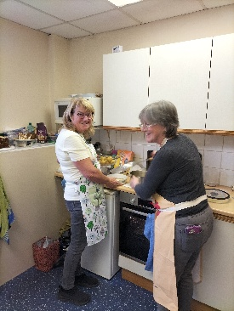
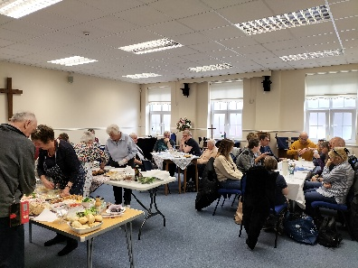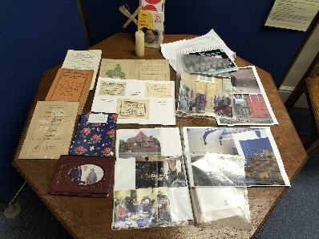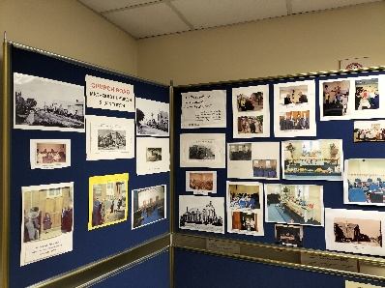
-ooooooooooooo-
Doncaster Methodist Circuit

Remembrance Sunday
On Remembrance Sunday, the Circuit honoured everyone who courageously gave their lives for our freedom, reflecting the sacrifice Jesus made for us. We thank God for the countless men and women worldwide who have fought, and continue to fight, for justice, peace, and respect among people.
This year marks eighty years since the end of the Second World War, commemorated by Remembrance Services in countries impacted by Nazi aggression and those that contributed volunteers to the fight.
It is important to acknowledge that many of the conflicts involving Britain’s service men and women are not distant historical events. Among these are the Falklands War, the Balkan Wars, the Gulf War, the Iraq War and the war in Afghanistan. Our Armed forces are currently keeping our skies and seas safe with patrols and gathering intelligence and also training other Nation’s service personnel to protect themselves.
We also remember the families left behind, those who lost loved ones and those families whose loved ones returned home broken, many dealing with Post Traumatic Stress Disorder and other physical or mental health challenges resulting from conflict.
We appreciate the ongoing support offered by medical services and charities to veterans and active military members. Below is a list of agencies available to provide help to those in need.
Currently, it is estimated that 32 to 56 conflicts exist around the globe, whether or not we are personally affected.
The prayer below, written by a thirteen-year-old girl for the millennium and displayed in the chapel at the National Memorial Arboretum, remains meaningful and relevant today.
Dear Lord, our Heavenly Father
In a world of darkness give us your light
In lands of war and prejudice grant us peace
In a world of despair give us hope
In a world of sadness and tears show us your joy
In a world of hatred show us your love
In a world of arrogance give us humility
In a world of disbelief give us faith
Give us courage to face the challenges
of feeding the hungry, clothing the naked
housing the homeless and healing the sick.
Give us the power to make a difference in your world
and to protect your creation.
THROUGH JESUS CHRIST OUR LORD.
Amen.
Anna Crompton Age 13 (displayed on the Chapel wall at the National Memorial Arboretum)
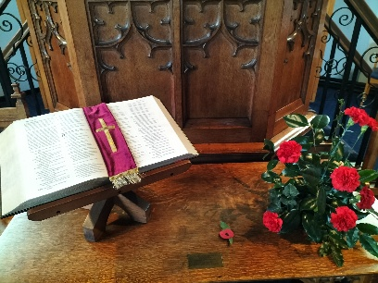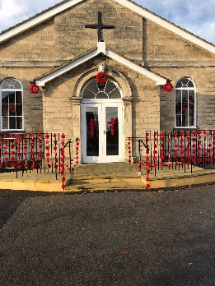
Bentley Methodist Church St Andrew’s Methodist Church Tickhill Methodist Church
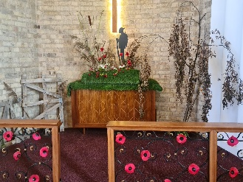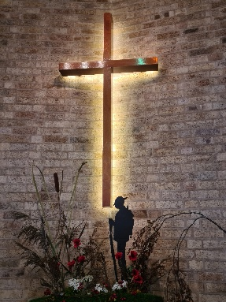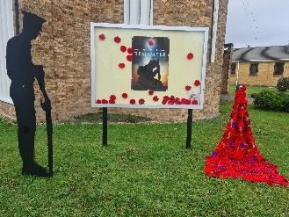
Cantley Methodist Church
-ooooooooooooo-
Alder Grove Methodist Church

Safeguarding Sunday

Alder Grove made one of their Own Arrangement services into Safeguarding Sunday. Led by Worship Team – members of the congregation played the parts of a homeless person, a pious Christian who offered to pray and a Christian with a conscience offering food and shelter.
Safeguarding work in our churches is a vital part of our ministry. If you are interested in conducting your own Safeguarding Sunday, please contact the Circuit Safeguarding Team or Circuit Office for further information.

-ooooooooooooo-
Auckley Methodist Church

Shoebox Appeal – Auckley doing it differently

One hundred and twenty-six Shoeboxes from Auckley have arrived in Ivano Frankivske in the Carpathian region of Ukraine. They are in store until Christmas Day when they will be given to children in an orphanage in that city.
It had always been frustrating, when packing Shoeboxes, not knowing where they would go. Also being told they might not be given out until January or February was unsatisfactory. People were much happier knowing they were going to Ukraine.

We had previously sent Shoeboxes through Operation Christmas Child. When the shoebox appeal started in 1990 it was intended simply to bring joy to children in orphanages in Romania. When OCC become part of Samaritan’s Purse I felt the ethos had changed to something I disagreed with an felt very uncomfortable with, so I started seriously looking for alternative routes. Through Hull4Ukraine I was put in touch with Steve at the Ukrainian Centre in Doncaster. My daughter and son in law took our 14 cartons into Doncaster for storage. Then on November 15th a lorry loaded with gifts sailed from Hull to Ukraine.

I’ve told all my donors, from six-year-old Brownies to eighty-odd year old aqua-fitters, that when they unwrap their presents on December 25th, they will be able to imagine a happy, excited child in Ivano Frankivske opening theirs. Because Ukraine, in a step away from Russia, in 2023 adopted western Christmas dates rather than the Eastern Orthodox 7th January.
Joan

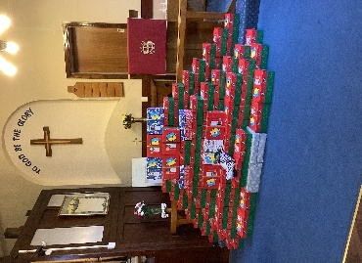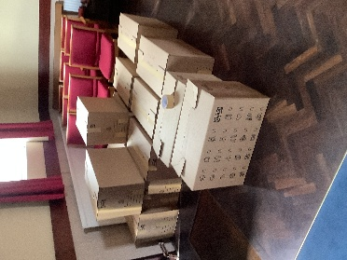

-ooooooooooooo-
Hatfield Woodhouse Methodist Church

Coffee Morning
Hatfield Woodhouse Methodist Church hold weekly coffee mornings/afternoons both on Saturday’s and Mondays. On 14th November a coffee morning was held to raise funds for Weston Park Cancer Charity. An amazing £1355 was raised for this very worthwhile charity. Well Done and Thank You to everyone who attended and contributed.
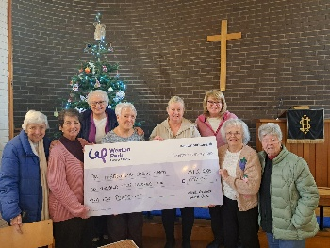
-ooooooooooooo-
Doncaster Methodist Circuit

Shoebox Appeal around the Circuit

Following the very sad loss of Marilyn Connell who was the Shoebox guru at Alder Grove Methodist Church, the mantle was taken up by David and Christine. With hard work and community spirit, over the course of a couple of Sundays after the service and a couple of Wednesday Coffee Mornings, approximately 25 shoeboxes were filled and sent to the drop off at St James’s Church, Balby Bridge.

Adwick Methodist Church held coffee mornings both to raise funds for the boxes and to fill them.

Cantley had a Shoebox coffee morning to raise funds and once completed, they held a Shoebox dedication service for their onward journey.

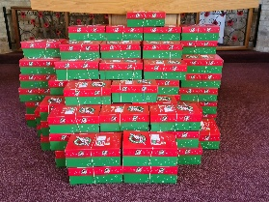Cantley Methodist Church
-ooooooooooooo-
Cantley Methodist Church

Circuit Advent Service
This year we held our Circuit Advent Service at Cantley Methodist Church.
It was a celebration of Advent led by Rev Tom Read with the address given by Rev John Henry.
Our readings were read by RE Team co-ordinator Aimee Roddan and Pastor Sean Worsley.
The church was full and the singing was loud!
Thank you to everyone who attended (despite the traffic disruptions with the Doncaster fun run).
Over £300 was raised for Mission in Britain.

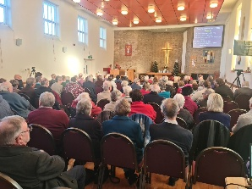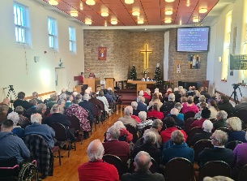
-ooooooooooooo-

DECEMBER 2025
St Andrew’s Methodist Church

2025 Candlelight Service

This year the theme was Kindness and Generosity and the chosen charity – Action for Children. Our guest preacher was Rev Chris Hawke, who was the Minister at St Andrew’s some year ago. It was lovely to see her.
The address reminded us to clothe ourselves in kindness every day – a small kindness can make a huge difference to someone else.

The lighting of the candles took place with over 30 candles being lit for various churches and charities throughout Doncaster, ending with the last candle lit for the YMCA and a prayer.

The afternoon ended in the Highfield Hall with visitors invited for refreshments and mince pies – a wonderful time of fellowship where friends not seen for a long while could catch up including or former minister, now retired Rev Jonathan Gicharra.
A total of over £360 pounds was raised for Action for Children.

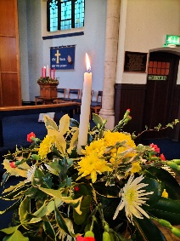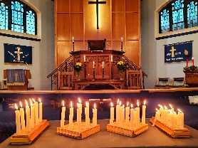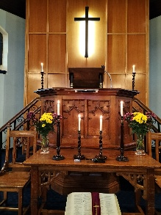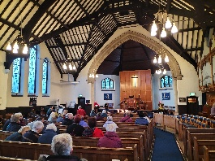

-ooooooooooooo-
Alder Grove Methodist Church
Alder Grove host Doncaster Hospice Memorial Service
For the first time, the Doncaster Hospice held their annual Memorial Service at Alder Grove Methodist Church. The team from the Hospice spent the day putting up Christmas Trees, fairy lights and creating spaces for reflection. The service was led by the Hospice Chaplains, a choir sang carols, service dogs were present to support and people were encouraged to write a memory or message and hang it on the memory tree.
Following the service, hot soup and refreshments were served in the hall – also decorated with Christmas trees.
Members at Alder Grove were proud to host this event.
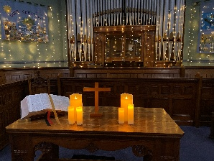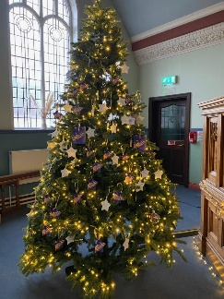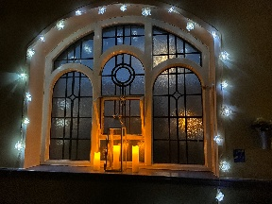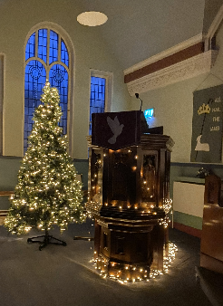
-ooooooooooooo-
Harworth Methodist Church

Harworth Methodist Church Christmas Tree Festival

I read in the Circuit News that Harworth Methodist Church were having a Christmas Tree Festival and had a fancy to go there.

Had not been to Harworth for many years so what we thought would be a 15-minute journey took much longer seeing that we went right by the church a few times, forgetting that it stood well back from the road!

A very kind, chatty and helpful person came out and guided us through a doorway and passageway - very convenient for a wheelchair.
We were introduced to family groups who were playing games, especially a family from Tonga!

After the usual Methodist cup of tea we went into the chapel to view the trees, mostly displayed on boards across the pews, but those near the communion table were free standing and some others too.
This small church looked so festive and delightful with the various organisations showing such creativity with their decorations and displays, in one case angels made from shuttlecocks!

We were entertained with a running commentary from our friend on the church itself and its work in the community, as we looked at the trees depicting local schools and walking and craft groups of this church.

One tree was eye catching with its rainbow colours, another which had no decoration of any sort at all was for the Food Bank with just a few food items on the floor round about - a strong message!

We left the church, pleased that we had paid them a visit and supported their event.
By Barbara Bewley

Donations raised over £300 for church funds.

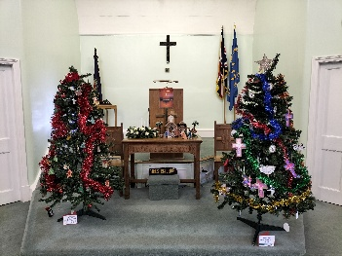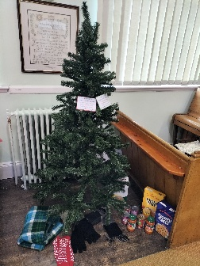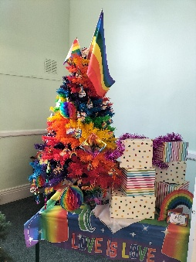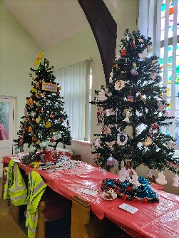
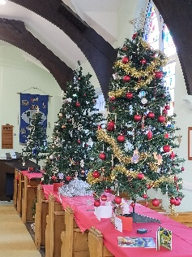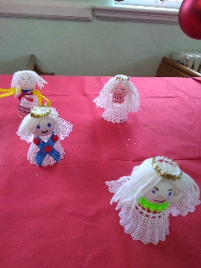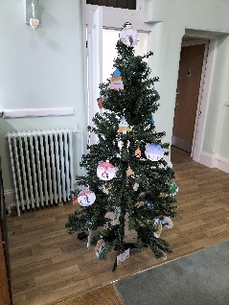
-ooooooooooooo-
Tickhill Methodist Church

Tickhill Angels

Quite a number of years ago, Susanna Brookes encouraged the chapels in Doncaster Methodist Circuit to knit or crochet Angels which would then be delivered to houses in each chapel's surrounding area.

Tickhill, along with quite a few other chapels joined in this venture and apart from a couple of adverse comments on social media (which were soon shouted down by more receptive people) the Angels have been welcomed into homes.

It must be our third or fourth set of Angels that have been produced this year, with ladies from the Craft & Chat Group knitting for over twelve months to produce 2,480, exceeding the 1,600 of last time three years ago.

On 5th December at the end of our Craft & Chat session, Rev John Henry came to dedicate our angels before they took flight the week beginning the 8th - and social media has been alive with comments. They have brought a smile to people who were feeling a bit down, and children look out for them on their way to and from school. A lot have been placed on Christmas Trees!

Thank you to the ladies who did all the knitting - one who is 95 produced 600!!! and thank you to those who helped them fly to most of the streets in Tickhill.
Eunice Randall – Tickhill Methodist Church

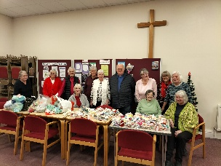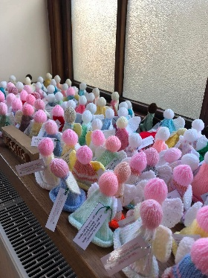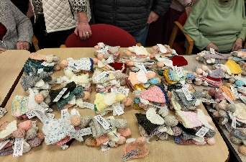

-ooooooooooooo-
Alder Grove Methodist Church

Alder Grove host Sycamore School

On Tuesday 16th December 2025 – Sycamore School, Balby were invited to Alder Grove Methodist Church for a short Christmas Service, craft and activities, led by June Rutherford

.

First on the agenda was a ‘Lamb Hunt’. The lambs from the church nativity scene had been hidden in the church – each with a name tag. The children had a set amount of time to find the lambs and tick them off a list.

The children were then split into three groups for craft – one table created a baby Jesus Christmas Card – colouring the image and sticking it to the card. The second table was a Christmas quiz and the third table (the most messy and sparkly), was cutting out an angel and decorating it with everything sparkle. The groups changed round so each child had the opportunity to create and test their knowledge of Christmas.

Once the craft was finished, the children enjoyed a drink and a specially made by June.

The children then settled down to a short story of Christmas night from the viewpoint of a shepherd trying to explain to his boss why he had left his shepherding duties. Carols were sung and a short prayer.

The children then gave us a treat by singing a few of the songs they had learned for their school play.

A very wonderful afternoon.

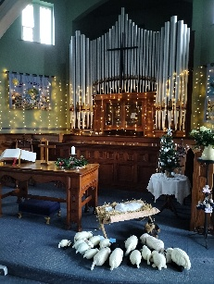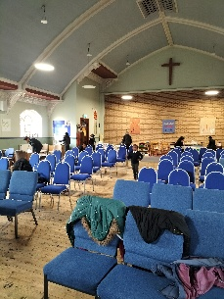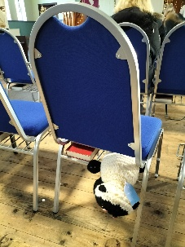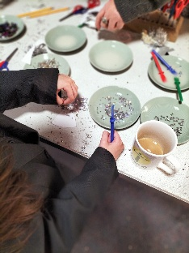

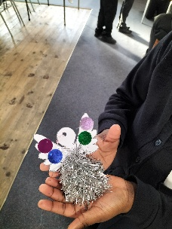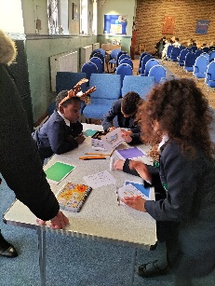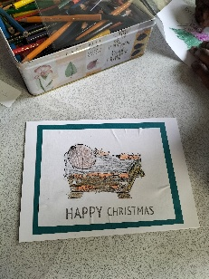

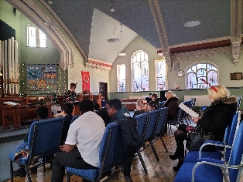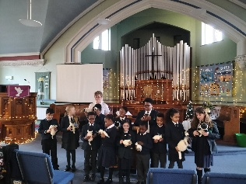

-ooooooooooooo-
Tickhill Methodist Church

Tickhill Methodist Outreach Team – Christmas Appeal
Thank you to the Doncaster circuit
On behalf of Tickhill Methodist Outreach Team and the homeless and vulnerable people we serve, I want to thank everyone who donated money and chocolate bars to our Christmas gift appeal. We were hoping for 60 chocolate bars and actually received 61 along with the fabulous sum of £1060! We were also able to purchase 60 thermal drinks bottles and clips for the bottles to be clipped to belts, bags etc.
We were very kindly donated a bag full of knitted beanie hats. A bag with a tag will be filled with a hat, a bottle and chocolate.
Your kindness and generosity is very much appreciated.
The gifts will be blessed at TMC carol service on Sunday 21st December then distributed on Monday evening when they are sure to be well-received.
Mandy

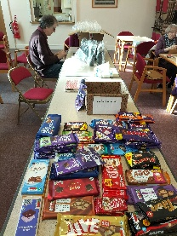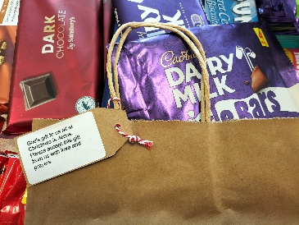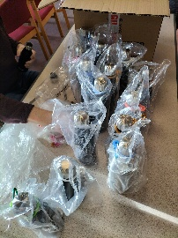

-ooooooooooooo-
Doncaster Methodist Circuit – Looking Forward to 2026
Dicipleship and Mission in the Name of Christ
2026 sees the 200th Anniversary of Thorne Methodist Church – look out for their celebrations throughout the year!
Please get in touch with your news so that I can add them to the next Extended Notices Summer edition or put them on the Website.
Don’t forget to follow us on Facebook. There are also some past services on Doncaster Methodist Circuit You Tube Channel.

Health, Happiness, Peace and Blessings to you all in 2026!

Thank you for reading.
Doncaster Methodist Circuit Office
Alder Grove Methodist Church
Alder Grove
Balby
Doncaster DN4 8RF
01302 850370
methodistcircuitdon@gmail.com

