Doncaster Methodist Circuit 
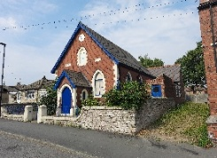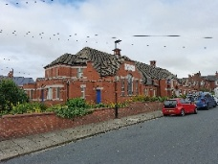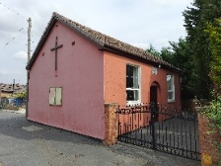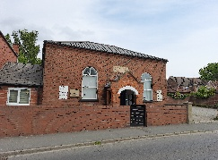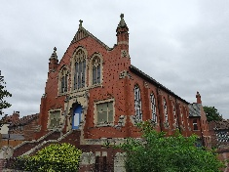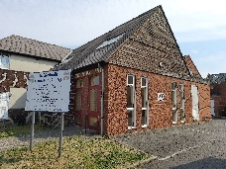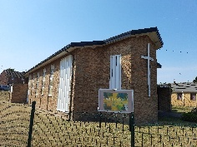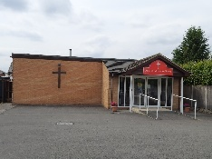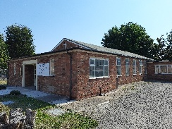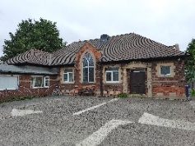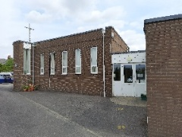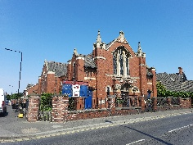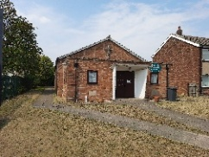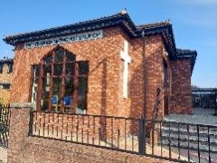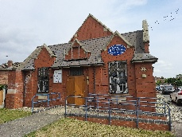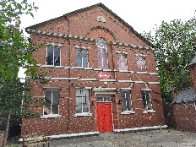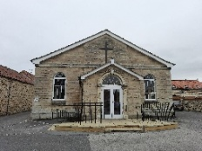

DISCIPLESHIP AND MISSION
IN THE NAME OF CHRIST
SUMMER EXTENDED NOTICES
CIRCUIT ACTIVITIES
Bible Study – Prayer Groups

Bible Study – Barnby Dun Methodist Chapel –
every 3rd Saturday @ 11.30 am following the coffee morning.

Bible Study – Cantley Methodist Church –
No set dates – check the Circuit Notices

Bible Study – Flintwood Methodist Church –
2nd Thursday of the month following– 3.00 pm- 4.00 pm

Bible Reflection – Hatfield Woodhouse Methodist Church –
1st Monday of the month – 1.30 pm – 2.00 pm

Bible Study/Discussion – Tickhill Methodist Church –
Wednesday Fellowship – weekly – 7.30 pm – 8.30 pm (not during school holidays)

Zoom Prayer – Hosted by Flintwood Methodist Church –
Weekly – Tuesday evening 7.30 pm – 8.30 pm (Zoom codes from Chris Ogley)

Prayer Time – Flintwood Methodist Church –
2nd Thursday of the month – 2.00 pm – 3.00 pm

Prayer Time – Thorne Methodist Church –
4th Saturday of the month – 10.30 am -11.00 am

Circuit Prayer Breakfast – 2nd Saturday of the month –
8.00 am – 9.30 am – visit a different church each month. Enjoy a free light breakfast and period of prayer. Check the Circuit Notices.
Other Activities
Weekday Holy Communion – SMC –
3rd Monday of the month – 2.00 pm – 3.00 pm using the Methodist Worship Book – led by Rev Tom Read.

CONNECT Contemporary Worship – Tickhill Methodist Church
A monthly contemporary service led by Rev John Henry.

Mission Matters Forum – a Circuit wide meeting to discuss matters that matter in Mission of our Churches, our Circuit, throughout Britain and the World. Check the Circuit Notices for dates and locations.

Fayres – Spring Summer Autumn and Winter fayres bring us together and give us an opportunity to support each other. Check the Circuit Notices for dates and locations.

February 2025 – Harworth Methodist Church
Supernumerary Winter Gathering
Retired Ministers and Deacons and their partners from around the Sheffield District meet twice a year (summer and winter), to enjoy fellowship, an act of worship and good food. These gatherings take place around the Sheffield District at a different Circuit each time. It was decided that the 2025 winter gathering would take place in the Doncaster Methodist Circuit and that Harworth Methodist Church would host the event.
With volunteers and outside help in place, we were all set on Wednesday 19th February to welcome 33 guests. Our guests started to arrive from 10.30 am where tea and coffee were served in the chapel with a backdrop of hymn tunes being played on the organ by Lorna. At 11.30 am an act of worship was opened by Rev Gill Newton, Chair of the District, and the service led by Pastor Sean Worsley.
By 12.30 pm the service had ended and everyone made their way into the hall, where a long table was set for everyone to enjoy the meal. Guests were treated to Yorkshire pudding, pigs in blankets, roast carrots and parsnips, mash potatoes and winter greens of kale and leeks. Turkey, gammon and delicious gravy. For pudding there was treacle sponge and custard or cheesecake with raspberry compote, all washed down with a cup of tea or coffee and an after dinner mint.
With the leftovers, we were able to send out extra meals in takeaway tubs to be enjoyed again the following day or passed on to people who were unable to attend due to ill health.
All in all, it was a wonderful event that was enjoyed by all!
Thank you from Rev Gill Newton and the Circuit to all the volunteers at Harworth who made it such an enjoyable event.
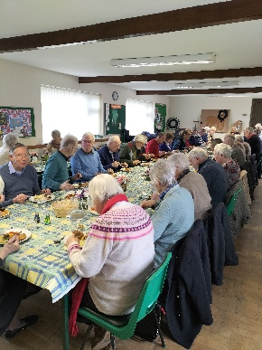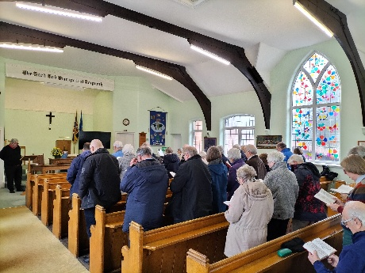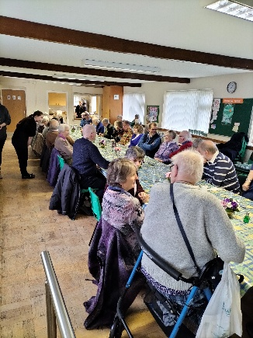

ooooooooooooo-
March 2025 – Harworth Methodist Church
Harworth Methodist Chapel Centenary Anniversary
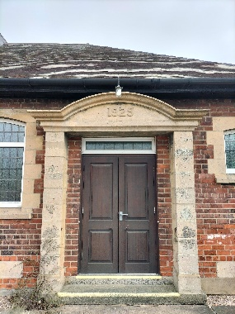

A special Centenary Service was held on Sunday 16th March 2025 celebrating 100 years of worship. The guest preacher was Alice Curry who had been Pastor at Harworth Methodist Chapel for several years prior to her retirement in 2023. Alice gave a history of World War I taking all the men from the villages, the Spanish flu which killed thousands and then the great depression of the 1930's. When many would hunker down and pull down the shutters the villagers of Harworth and Bircotes decided to build and open a church – a Methodist Chapel – being a place of hope, peace and the comfort of knowing Jesus Christ during a time of worry, loss and sadness.
Harworth Chapel went from strength to strength with groups for the community and activities including Women's Bright Hour and Girls Brigade, craft groups, coffee mornings, meals for Age Concern, Community Choir and the annual Entertainment Evening of singing, comedy and fun (to name but a few). During the service Alice encouraged people to share their memories. One memory being the annual Strawberry Tea Party's on the lawn in front of chapel bringing many local residents in to share in a bowl of strawberries and cream.
Lorna, the Organist told how she had been the organist from standing in to play at Sunday School up to today – 70 years of service to the chapel and congregation!!!
Alice spoke of the net that was cast from Harworth Methodist Chapel that goes far and wide. Everyone was given a piece of paper to make an origami fish to make – with the bible reading from John 21 v 1-27. The unbreakable net holding 153 different types of fish – just as Harworth Chapel as a church pull in and welcome people from Every Place.
Following the service, which was attended by the Harworth regulars, the Sunday School and friends from around the Circuit, a bring-and-share lunch was enjoyed in the hall. A special cake had been made and sat on a cloth embroidered with the names of the ladies from the Women's Bright Hour. There were photographs of past celebrations to reminisce. It was a wonderful celebration of the life of Harworth Chapel. HAPPY BIRTHDAY and Congratulations.
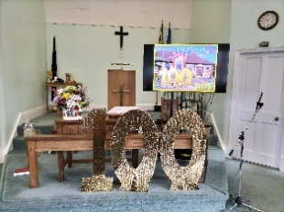
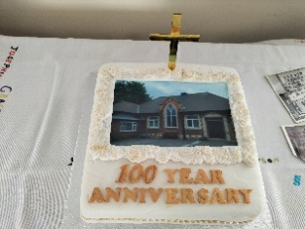
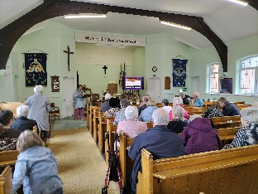
ooooooooooooo-
APRIL 2025
EASTER 2025

Across the Circuit we celebrated Easter Week.
At Cantley Methodist Church a Maundy Thursday Holy Communion service was held in the evening.
Good Friday saw the very well attended Passion 4 Doncaster Ecumenical service at the Doncaster Market Corn Exchange – this was so well attended people were stood outside! Many members of the Doncaster Circuit were present and enjoyed the fellowship, singing and message that Good Friday = Good News.
In the Circuit, SMC held a service of Reflection with music, readings and a space to think and pray.
Stainforth Methodist Church held a Good Friday service.
In the afternoon a Good Friday service was held at Cantley Methodist Church. Later that day a Good Friday service was held at Auckley Methodist Church where the congregation left the service in silence to reflect the solemn and sombre mood of the crucifixion of Jesus.
Thorne Methodist Church held their Spring Fayre on Saturday which was well attended and full of joy and fellowship.
Easter Day – churches across the Circuit held their Easter Day services. Here's a snapshot of a few services:-
SMC had visiting preacher – Chair of District Rev Gill Newton – click the link to watch the full service on the SMC YouTube Channel. https://www.youtube.com/watch?v=aHF0da25ZM8
Cantley Methodist Church, the cross was decorated with flowers and placed outside for all to see – a symbol of new life. The Good News of Jesus Christ resurrected and gaining a new life after his death for the forgiveness of all our sins.
Alder Grove Methodist Church had an Own Arrangement service. An Easter Garden was created and the Cross was decorated with pots of flowers around its base
St Andrew's Methodist Church, Wheatley was an Own Arrangement service where at the beginning of the service a glass of yeast was fed with water, sugar and salt – during the service this continued to grow. A small amount of yeast transforms a large batch of dough, so can a little faith and devotion in the love that Jesus Christ has for us make a significant difference in the lives of individuals and society as a whole.
A wonderful Easter Weekend!
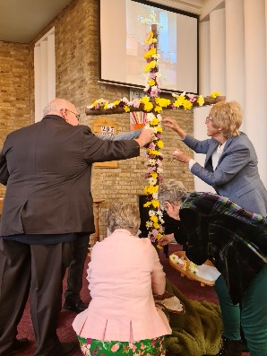
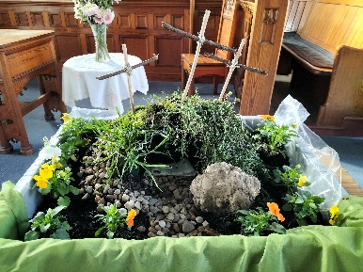

Cantley Methodist Church Alder Grove Methodist
Church

-ooooooooooooo-

My Favourite Hymn

“GIVE TO ME, LORD, A THANKFUL HEART”
548 Hymns and Psalms 520 Singing the Faith

This hymn was written by The Rev. Thomas Caryl Micklem (1 August 1925 – 2 June 2003). He was a minister in the Congregational and United Reformed churches, a hymn writer and a religious broadcaster. He was born in Oxford into a family steeped in nonconformist tradition, and was educated at Mill Hill School and New College, Oxford. He served on the editorial board of “Hymns and Psalms” and also served as Chairman of the Hymn Society of Great Britain and Ireland from 1993 to 1999.

As a hymn writer he was just as skilled at writing tunes for his own words as is shown by the fine tune for this hymn, “Gatescarth” – Gatescath Pass is in the Lake District.

Google says the Christian name “Caryl” is derived from Old English and it holds the meaning of Free Person or Song. The name's etymology showcases its deep connection to personal liberty and musical expression.

When I was in my teens I read a book on “Prayer” which influenced me greatly, written by Harry Emerson Fosdick (May 24, 1878 – October 5, 1969), who was an American pastor in New York. One of the chapters in the book is entitled “Prayer is dominant desire.” He explained that everybody prays, whether they be religious or not, and “dominant desire” must be their motivation if they want to achieve anything worthwhile.

An example of this is the career of Jo-Flo (Florence Griffith Joyner), the fastest woman in the world in 1988. Her dominant desire was to be the Olympic champion and though she died when she was 39 she still is the current record holder of the Women’s 100 metres at 10.49 seconds as ratified by the International Association of Athletics Federations.

Another person who knew what dominant desire meant was the great 19th century German composer Johnnes Brahms. While he was still engaged to be married he realised that his dominant desire
was to devote all his energy to composing classical music; so he wrote his fiancée a letter cancelling the engagement – poor girl!

Another person who showed what dominant desire meant was one of my heroes, Albert Schweitzer. He was a theologian, organist, musicologist, writer, humanitarian, philosopher, and physician. However, as is well known, his dominant desire was most famously
shown in founding and sustaining the Hôpital Albert Schweitzer in Lambaréné, French Equatorial Africa (now Gabon).

“Give to me, Lord, a thankful heart” is a prayer and it is my own dominant desire. Unfortunately, I cannot live up to it even though, when I cannot sleep, I sing it to myself! But I do take heart from the words of John Newton:
“I am not what I ought to be,
I am not what I want to be,
I am not what I hope to be in another world;
but still I am not what I once used to be,
and by the grace of God, I am what I am.”

You probably know that John Newton, whose famous hymn “Amazing Grace” was written in 1772, was once the captain of a slave ship but converted to Christianity, ending up as a curate in Olney, Buckingshire. Olney Hymns were first published in February 1779 and are the combined work of curate John Newton (1725–1807) and his poet friend William Cowper (1731–1800). The hymns were written for use in Newton's rural parish, which was made up of relatively poor and uneducated followers. My second cousin Linda has traced the Harris family tree back to this time and this place, and my great great grandfather and grandmother were probably members of John Newton’s congregation.

Give to me, Lord, a thankful heart and a discerning mind:
How important it is to be thankful! One of our members at Adwick Methodists was telling us about a coach trip she has just been on where people never stopped moaning. As the old hymn suggests: “Count your blessings!”
In the 21st century with its fake news, telephone scams and bogus emails it is right to pray for “a discerning mind.”

Someone once asked George Bernard Shaw who was the person he most missed in his life. He replied, “The man I used to be!”
The second verse of the hymn says, “When in the rush of days, my will is habit bound and slow” – I wish I were a few years younger!

I find the last verse of this hymn:
Jesus, with all your church I long
To see your kingdom come:
very moving especially the last line:
“Until you bring me home!

By Peter Harris of Adwick-Le-Street Methodist Church
-ooooooooooooo-

April 2025 – Adwick-Le-Street Methodist Church

Volunteering in CAMBODIA in July 2025 – Louie and Tu Luke
On Saturday 26th April 2025, Adwick Methodists were very pleased to hold a Coffee Morning (which raised £570) to support two 16 yr olds who are leaving Manchester Airport in July on a school trip of a
lifetime to Cambodia, a beautiful country in South Asia. "The Kingdom of Cambodia" has a population of approximately 17 million, but it is a very poor country with the people having an average yearly income of 2,948 international dollars.
Whilst they are there, Louie and Tu Luke will be living and working within the local community, so they will be immersed in local life. They may be helping to dig foundations for a classroom, collecting rubbish to be recycled or planting trees – helping to change the locals' lives one day at a time.
We are looking forward to their return when they have promised to teel us all about their exploits and adventures!
by Peter Harris of Adwick-Le-Street Methodist Church
Good Luck and God Bless Louie and Tu Luke

-ooooooooooooo-

May 2025 – Stainforth Methodist Church

Celebration of VE Day 80th Anniversary on 8th May 2025, at Stainforth Methodist Church.
On this day Steve Willimott led a meaningful service of Thanksgiving and Remembrance. The service ended with the National Anthem.
The Church inside and outside had been decorated with bunting. Also had some sound effects. We decided to have a themed meal. Many suggestions for the menu.
The food chosen was corn beef hash, cottage pie and potato, cheese and onion on a pastry base. We used frozen mushy peas, more today’s food, I think. The sandwiches were potted meat and homemade fish paste. Puds and desserts, Trifle (a staple of many chapel teas) apple pie, seasonal strawberries with evaporated milk or fresh cream (from local cows), war time Utility Loaf (just made a loaf today, recipe available). Gave the war time vanilla slices a miss, a bit fiddly to make, unless you are proficient at cutting a cream cracker in half. They are not particularly tasty, a bit bland. We ate to the background music of Vera Lynn.
About 30 children and adults attended. I think the children enjoyed the sound effects as well as the food plus the hands-on table decorations. Some of the helpers dressed in 1940’s dress. Thank you, Elaine, for making the wrap over aprons.

A celebration after hardship.

Remembrance after 6 years of war which continued until August 1945.

Thank you to that generation of men and women.

“When a thankful nation, looking back, has cause to celebrate
those who win our admiration by their service to the state;
when self-giving is a measure of the greatness of the great:
may the living God be Praised”.

-ooooooooooooo-

May 2025 – SMC

Easter Offering Service 2025


The Easter Offering Service was held on Sunday 11th May 2025 at SMC. There was a well-attended tea beforehand serving sandwiches and cakes.
The service continued despite there being a power cut in Sprotbrough. Friends from all over the Circuit attended. The service was led by Jane Bingham. Readings, prayers and life stories from the Education for All – Hope for All Easter Offering service book were given by members of the Doncaster MWiB including representatives from Thorne and SMC.
The address was delivered by guest preacher, Rev'd Dr. Andrew Ashdown, who serves as the Partnership Coordinator for Africa (Methodist Church in Britain). Rev. Ashdown, an Anglican Priest working for the Methodist Church, commenced his address by commending the efforts undertaken by the Methodist Church across Africa. The support provided by the World Mission Fund throughout Africa is enabling individuals – both children and adults – to receive education. This assistance facilitates the learning of trades, the establishment of businesses and the acquisition of funds to benefit their communities.
The presence of the Methodist Church extends to even the most remote areas of Africa, in addition to the bustling towns and cities. Climate change is having a significant impact on African countries, making it essential to educate both children and adults on how to adapt to these changes to prevent losses of crops, livestock, food, and lives during alternating periods of drought and floods.
The Methodist World Mission Fund has successfully provided funding in Zimbabwe for a farm expert who has established a farm near two schools. This farm now cultivates 5,000 tomato plants, raises 5,000 chickens, and maintains 90-100 pigs. Some of the produce is sold to local hotels, generating additional income for the community.
In Zimbabwe, grants have facilitated the transformation of a run-down youth centre into a factory for producing school uniforms. This initiative provides affordable uniforms for children whose parents are unable to afford them at regular prices. Reverend Ashdown highlighted that children without uniforms are not permitted to attend school. Consequently, this project not only enables more children to receive an education but also generates income for the church.
Rev. Ashdown provided numerous compelling examples of how the Methodist Church and the World Mission Fund are supporting local initiatives. He stated, "It is not solely about what we can do, but also about what we receive – a greater level of faith, perseverance, and commitment." The Methodist Church Partnership operates globally to promote Methodist principles, including service and commitment, love and respect for all individuals, particularly those who are marginalized.
Even without electricity to power the piano, lighting and microphones – it was a truly uplifting service.
Great thanks to SMC for hosting the afternoon tea and service.
Please click the link to read Blogs by Rev Dr Andrew Ashdown about his work across 21 countries in Africa under his wing.
https://worldchurchrelationships.wordpress.com/

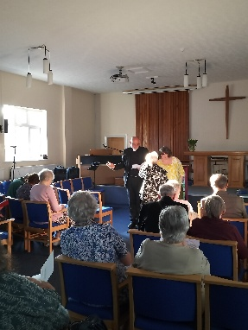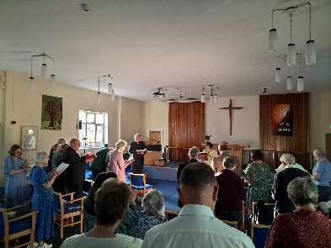
-ooooooooooooo-

News from our Friend and Local Preacher Susanna
Hello everyone. It has been lovely seeing lots of you as I have preached around the circuit over the past couple of years since stepping down as one of the Pastors.
One of the things that lots of you have kindly said is how much you enjoyed reading my letters through covid, so I thought that I would send a little follow up.
You may be surprised/happy/relieved to know that Slabgate is complete!!! To be fair he did a really good job and worked hard. We have even got rid of the spare slabs to the next person to embark on a project like that now too. Project ‘Get The Garden Ready For The Daughter’s 18th Birthday’ is well underway now and will probably have taken place by the time you read this. I am overrun with fairy lights, and pink decorations for the occasion at present, which is all very lovely. Prayers for suitable weather would be appreciated, as my family are all coming up from Cornwall, and with other guests it will be a tight squeeze if we need to stay indoors! (Not to mention disappointing after all the work that’s going into the garden.)
I am loving how everything is maturing in the garden more now though. The birds are loving the fat balls I put out too at the moment – they don’t last more than about 2/3 days before needing a refill.
We have a second dog now too. Phoebe our black lab is 10 now, and a friend of mine needed to rehome their cocker spaniel so we now have Skyla with us too. She’s lovely and full of beans as you can imagine. We have had her for 3 years now, and she is 5 but still acts like a puppy most of the time.
I must finish now, but I hope that you all have a lovely summer.
God bless
Susanna (Brookes)
-ooooooooooooo-

June 2025 – Barnby Dun Methodist Chapel

Barnby Dun Chapel

150th Anniversary Sesquicentennial
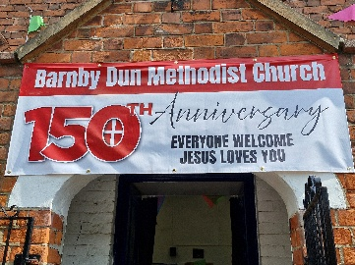
Barnby Dun chapel was founded in 1875 and was originally a Primitive Methodist church. Historically, Sunday School and Women's Fellowship were a large part of church life. Currently held are a weekly coffee morning (weather dependent in winter), with popular fayres in Spring and at Christmas and a weekly 10.30 am service. A new bible study group is now being held every third Saturday following on from the coffee morning.
The sesquicentennial celebrations started on Saturday 14th June 2025 with an open house. Over 22 visitors attended over the course of the day, with refreshments served and plenty of photographs and memories shared. A new cross erected on the outside of the building has been made and generously donated by the Friday Men's Club, bunting hung and other decorations and artifacts to stir the memory on display.
On Sunday 15th June 2025 the service was led by Rev Tom Read (who taught us the word sesquicentennial). Not only a service of celebration for 150 years of Faith, Discipleship and Mission but also Pentecost. A reading from Acts 11 reminded us that the tensions and fears we hold today, are the same as those felt all those years ago; a tension of what we have always done and are comfortable with wrestling with what the Spirit is leading us to do.
Reverend Tom reflected on the excitement that must have been felt on the opening day of the new Primitive Methodist Chapel by the farmers, labourers, farmhands, and their families in their village. He expressed gratitude to all those who came before us and recognised the faith they held and passed down through successive generations.
How many baptisms, weddings, funerals? How many hymns sung, prayers said, sermons preached? How many friendships forged? How many cups of tea served over 150 years!
How do we celebrate 150 years but move forward? Consideration should be given whether we still understand the purpose behind long-standing traditions or if their meanings have been eroded over time and merely upheld out of habit. Feelings of disorientation and defensiveness may arise in the face of change or challenge. It is important to prayerfully reflect and consider what the Spirit is leading us to do. "Who am I to think that I can stand in God's way?"
After Holy Communion was shared, the congregation left the building to stand outside when Rev Tom led a short dedication to the new Cross, donated by the Friday Men's Club, now on display on the Chapel Wall. A fitting end to a celebration service.
Wonderful cakes and drinks were served following the service – more memories and fellowship shared.

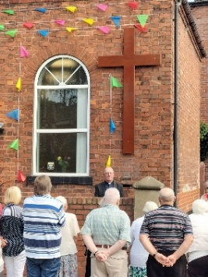
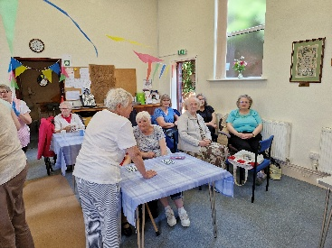
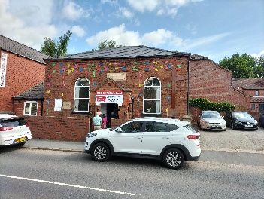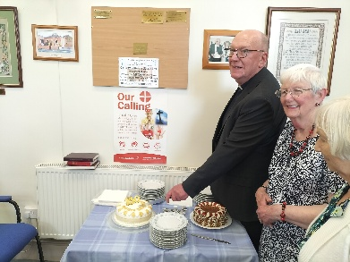

-ooooooooooooo-

June 2025 – Adwick-Le-Street Methodist Church

Summer Fayer with a Difference!

This year our Social Committee threw caution to the winds and said, “Let’s make the focal point of the Summer Fayre an Afternoon Tea à la Ritz” – so they did!
They still had a tombola table, a raffle and all the usual stalls, but the Afternoon Tea took precedence with white tablecloths, china crockery, cake stands, sandwich trays and waitress service – fabulous!
As the photos show, a wonderful occasion, and £401.50 was raised for church funds.
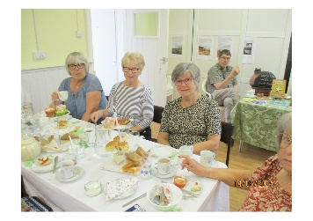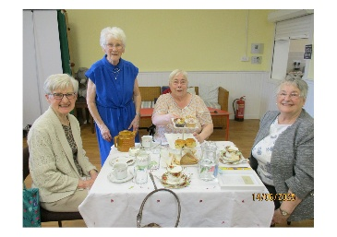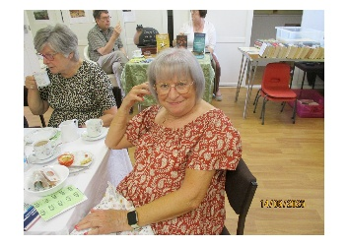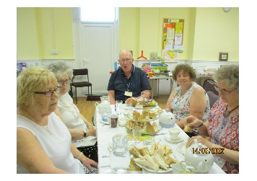
-ooooooooooooo-

Please get in touch with your news so that I can add them to the next Extended Notices Autumn edition or put them on the Website.

Don’t forget to follow us on Facebook. There are also some past services on Doncaster Methodist Circuit You Tube Channel.

Thank you for reading.
Doncaster Methodist Circuit Office
Alder Grove Methodist Church
Alder Grove
Balby
Doncaster DN4 8RF
01302 850370
methodistcircuitdon@gmail.com

