**Lone Working Policy for Volunteers**

XXXXXXX Methodist Church is committed to providing a safe environment for volunteers. This policy lays out the responsibilities with regard to working alone in the building or grounds. The risk assessment is to be reviewed annually or more frequently if there is any incident involving someone working alone.

# Introduction

At times, many church volunteers will be in situations where they are a 'lone worker'. The recommendations below try to be realistic about what can and cannot be put in place. Whilst it must be recognised that the Church does not have the structure associated with a large business, its aims to be a good employer, concerned about the safety of employees including volunteers.

Under the Health and Safety at Work Act 1974 and the Management of Health and Safety at Work Regulations 1999, the employer has a duty of care to advise and assess risk for workers when they work by themselves in these circumstances. However, employees and volunteers have responsibilities to take reasonable care of themselves and other people affected by their work.

# Aims of the Policy

The aim of the policy is to:

* Increase volunteer’s awareness of safety issues relating to lone working.
* Ensure that the risk of lone working is assessed in a systematic and ongoing way, and that safe systems and methods of work are put in place to reduce the risk so far as is reasonably practicable.
* Ensure that appropriate support is available to volunteers that equips them to recognise risk and provides practical advice on safety when working alone.
* Encourage full reporting and recording of all adverse incidents relating to lone working.
* Reduce the number of incidents and injuries to volunteers related to lone working.

# Church council’s responsibilities

* Identify staff and volunteers who are lone workers.
* Inform staff and volunteers of their responsibilities under the Lone Working Policy.
* Ensure all new staff and volunteers are aware of Lone Working protocols.
* Ensure that a risk assessment has been completed and documented and is regularly reviewed. A formal Risk Assessment is needed for lay workers and Presbyters.
* Put procedures in place which are designed to eliminate or reduce the risks associated with Lone Working
* Define limits of what cannot be done while working alone
* Ensure that staff and volunteers identified as being at risk are given appropriate information, instruction and training.

# Staff and Volunteer Responsibilities

* It is the responsibility of all volunteers to take care of themselves.
* They should never knowingly put themselves at risk.
* Ensure they read, understand and comply with the Lone Working policy.
* Participate in the risk assessment process to reduce the risk associated with lone working. Any incidents should be recorded in the accident book kept in the office.

# Good Practice for Lone Workers

* All employees and volunteers leaving the workplace (or home) to undertake workrelated tasks alone should consider leaving details of where they are going and their estimated time of arrival back at base.
* When arranging one-to-one meetings, employees and volunteers should consider whether contact could take place in an environment where confidentiality could be maintained but others would be in the vicinity.
* Lone workers should have access to adequate first-aid facilities.
* Lone workers should be provided with a mobile phone and other personal safety equipment where this is necessary.

# Risk Assessments

The current risk assessment follows, and forms part of this policy.

For reviewing the lone working risk assessment the following questions will be considered:

* Is it necessary for the individual to work alone?
* Does the workplace or task present a special risk to the lone worker?
* Is there a safe means of entry and exit?
* Is there any cash or valuables on the premises?
* Do lone workers have knowledge of the hazards and risks to which they are possibly being exposed?
* Do lone workers know what to do if something goes wrong?
* Does someone else know the whereabouts of the lone workers and what they are doing?
* Are there adequate channels of communication in an emergency?
* Is the person medically fit and suitable to work alone?
* Is there a risk of violence?
* Are women especially at risk if they work alone?
* Is any known risk attached to a home visit?
* Has an alternative to a home visit been considered?
* Has safe travelling between appointments been arranged?
* Have reporting and recording arrangements been made where appropriate?

# Lone Working Risk Assessment

Use this to assess your environment, and your working practices, as well as for an instant assessment of a situation.

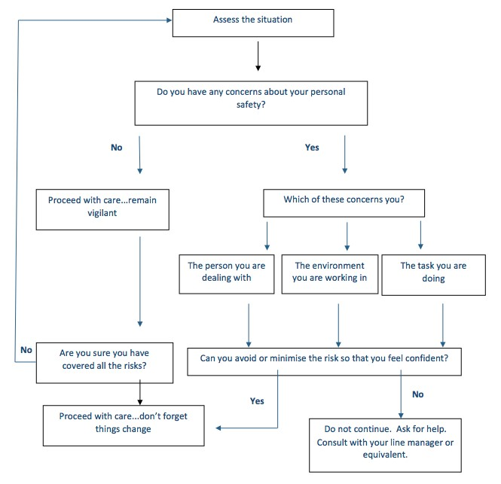

From Personal Safety at Work, Suzy Lamplugh Trust 2006, revised 2008